INFS4205/7205 Recommended Report Structure
To help you organise the project, the following report structure is recommended (Not limited to the provided questions):
MAXIMUM 4 PAGES (Allow appendix)

1. Introduction

What problem are you solving?
This project solves the problem of building a personalised multimodal study assistant for my own course materials.
General LLMs often provide fluent but generic answers that are not well-grounded in my notes, lecture slides, and figures. The system addresses this by integrating a personalised knowledge base (course PDFs, extracted text chunks, image/figure metadata, and user profile), retrieval, and agent orchestration to generate grounded responses for factual, cross-modal, multi-hop, and follow-up queries.

Why is it interesting?
This is interesting as a systems design problem rather than just a chatbot implementation.
It requires balancing answer quality and system cost: adding routing, memory, and multimodal retrieval can improve grounding and personalization, but may increase latency and tool usage. It also provides a concrete way to study whether multimodal evidence and agentic orchestration produce measurable gains over simpler baselines.

What is your design hypothesis?
H1 (quality): A LangGraph-style agent with hybrid retrieval (BM25 + vector), routing, and memory will outperform plain LLM and simplified RAG baselines on retrieval quality and answer quality, especially for cross-modal and follow-up queries.
H2 (systems trade-off): These quality gains come with higher system overhead (latency, tool calls, and token usage).
H3 (personalization effect): Injecting user profile and conversation context improves follow-up query performance compared with retrieval-only variants.

2. Knowledge Base Construction
What data did you collect?
Why is it personalised?
What modalities are included?

What data did you collect?
I collected a personalised academic knowledge base centered on my own course materials.
The dataset includes:
- PDF lecture slides and practical class notes (converted into text chunks with source metadata),
- image/figure records represented by captions and tags (from course figures and visual content), and
- a user profile file describing my study preferences (e.g., weak topics, preferred response style, and time constraints).

Why is it personalised?
The dataset is personalised because it is built from my own study context rather than a generic public corpus.
It reflects my enrolled courses, my revision priorities, and my learning preferences. The agent also uses this profile during routing/memory steps to adapt follow-up responses (e.g., concise revision-focused answers for weak topics), which makes retrieval and generation user-specific.

What modalities are included?
The system includes two modalities:
- Text modality: lecture/practical content extracted from PDFs as searchable text chunks.
- Image-metadata modality: figure/image information represented through captions, tags, and source references.
So the multimodal setting is implemented as Text + Image Metadata within a unified retrieval pipeline

- Retrieval / Representation Design
How is the knowledge represented?
What embedding/indexing strategies are used?
What design alternatives are considered?

How is the knowledge represented?
Knowledge is represented as a structured multimodal corpus with unified document records.
Text from course PDFs is chunked into JSONL entries with fields such as id, course, title, content, week, source_file, and topic_tags.
Image-related knowledge is represented as metadata records (caption, topic_tags, source_image, optional related_text_id) instead of raw pixel-level reasoning.
A separate user profile JSON stores personalized preferences (weak topics, revision style, time budget), which is injected during follow-up reasoning.

What embedding/indexing strategies are used?
The system uses a hybrid retrieval strategy:
- Lexical index: BM25 over text + metadata fields.
- Vector representation: TF-IDF-based vectors for document/query embeddings.
- Vector index backend: FAISS (IndexFlatIP) when available; otherwise cosine similarity fallback.
- Fusion: normalized score fusion of BM25 and vector scores, then Top-k evidence selection.
This combines exact keyword matching with semantic similarity and supports robust retrieval across factual and cross-modal queries.

What design alternatives are considered?
Three explicit system variants are evaluated:
- V0 (Plain LLM): no retrieval, no memory.
- V1 (RAG without memory/router): hybrid retrieval + fixed pipeline.
- V2 (Final agent): routing + memory + hybrid retrieval.
Additional design alternatives considered in analysis:
- text-only retrieval vs text + image-metadata retrieval,
- no-memory vs memory for follow-up personalization,
- fixed pipeline vs routed tool-based workflow.
These alternatives are compared quantitatively to analyze both quality gains and system overhead.

4. Agent Workflow
How does the system process a user query?
What tools, states, or routing steps are involved?
Why is an agent needed?
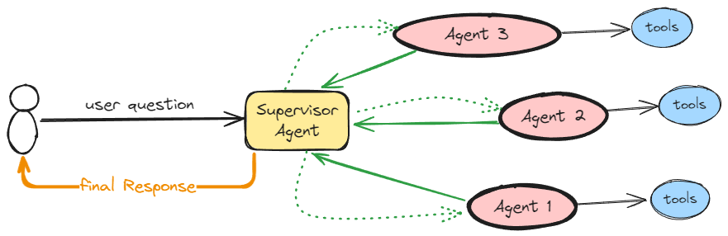
Figure 1Demo Figure

5. Experimental Setup
What baselines are compared?
What query families are tested?
What metrics are used?

6. Results and Analysis
What works best and why?
What trade-offs did you observe?
What did the ablations reveal?
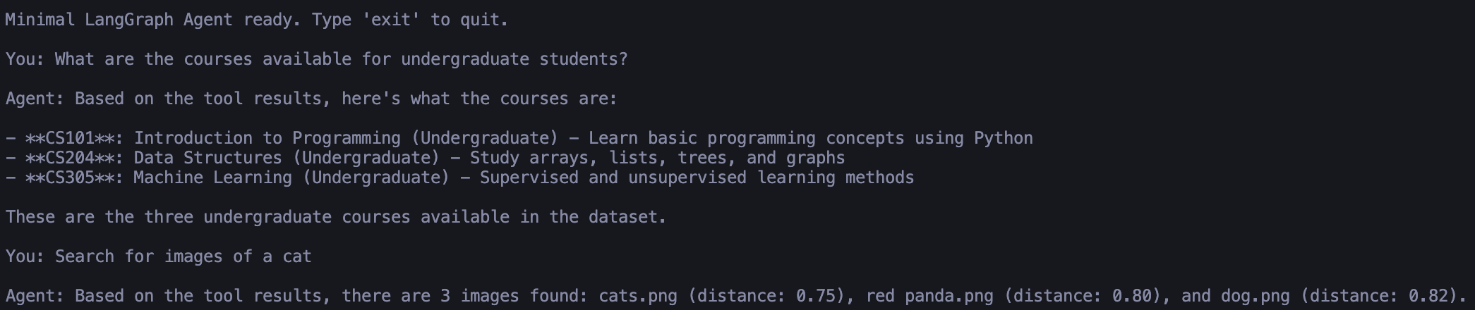
Figure 2 Demo Figure

7. Failure Cases
Where does the system break?
Are failures caused by retrieval, reasoning, or orchestration?

8. Conclusion
What did you learn from the project?

